Graphical Analyzer Test of Misconception of 45º Angle as Optimal Angle in Projectile Motion

Shidiq Andhika, Riki Purnama Putra , Anissa Nurul Fitriani, Yunissa Cesariyanti, Rena Denya Agustina

UIN Sunan Gunung Djati
Jl. Cimencrang, Kec. Gedebage, Bandung City, West Java. 40292, Indonesia
|fullmariki20@gmail.com | DOI: https://doi.org/10.37729/radiasi.v17i2.896 |

Abstract | Article Info:  Recieved:  13/04/2023  Revised:  23/08/2024  Accepted:  05/09/2024
Misconceptions still often occur when learning physics, especially in conducting research that is not consistently detailed in identifying an observation. In parabolic motion material, it is known that 45° is a special angle that produces the farthest distance. The misconception that 45° is the angle that produces the farthest distance has become a reference in learning in various educational institutions to date. The aim of this research is to identify and prove that the 45° angle is not an elevation angle that produces the farthest distance in a vacuum that ignores the initial position of the thrower. This research was conducted using PhET virtual laboratory media which was analyzed based on quantitative and qualitative methods. This study will test the elevation angle of 42° : 45° : 48° based on altitude 0 m : 1 m : 2 m. After the observational data has been obtained and proven by the existing equations, the research results will be analyzed based on the functional analyzer approach by making the equations into function graphs to make it easier for readers to read the existing data. In this study, it was found that the angle of 42° is the producer of the farthest distance and also gets a relatively faster travel time compared to the angle of 45° which we know so far as a special angle that produces the farthest distance in non-vacuum conditions. In this study, it is hoped that readers will be able to re-examine the point of producing the furthest distance which is still a misconception in various educational institutions.

Keywords: Parabolic motion, Misconception, Virtual laboratory

Introduction
Physics is one of the most difficult subjects in natural sciences. Physics is the science that studies the properties, natural phenomena, and all the interactions that occur in them. Through this interaction, physics can help to understand the mysteries of the universe [1]. To study it, physics itself can use methods that start from observation, measurement, analysis, and conclusions. Basically, many things that happen in everyday life are interesting and can be found using physics concepts, including the concept of parabolic motion. It is understood that any moving object will follow a certain trajectory. Based on this trajectory, motion is divided into straight motion, circular motion and parabolic motion or also known as bullet motion. In 1638 in the last part of the dialogues concerning two new sciences, Galileo showed by geometrical means that in a vacuum, the trajectory described by a projectile is a parabola [2],[3].
The proof of a parabolic trajectory is obtained by combining unaccelerated horizontal motion with accelerated vertical motion. In dialogues Galileo also discusses, through his character, the effect of air resistance on projectile motion and admits that parabolic trajectories are unreal [4]. One of the importance of understanding projectile motion is that this concept can be used to analyze several events in the field of sports, such as analyzing the motion of a curved ball in a soccer match and the motion of a shuttlecock in badminton [5]. According to the laws of physics, the movement of the ball will cause a flow of air around it, the faster the air flows, the lower the pressure. Unknowingly in the game of football there is a physics concept about parabolic motion [6]. We can find another understanding in the research conducted by [7], that when a jumper makes a jump in the air it does not always produce the farthest distance at an angle of 45°, this is only a reference in projecting a measurable optimal movement. Parabolic motion is a motion whose trajectory is a parabola. Parabolic motion is a two-dimensional motion, which combines two axes, namely the horizontal axis and the vertical axis [8].
The motion of the bullet is a two-dimensional motion of the particles thrown obliquely into the air. In this motion, the effect of friction with air is considered absent or ignored. When the ball is kicked by forming a certain angle which is called the elevation angle, the path that the ball takes is in the form of a curved line or a parabolic path of motion, which can be seen in Figure 1[9].

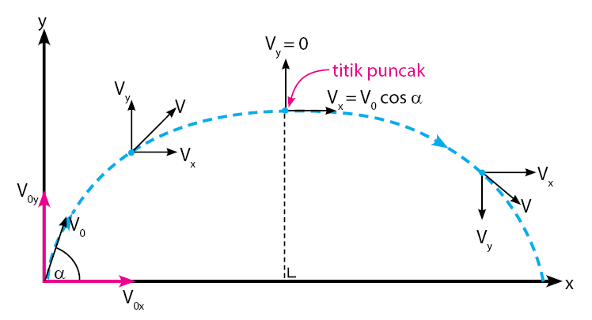
Figure 1. Trajectory and Variables of Parabolic Motion
In parabolic motion, the motion of objects in the vertical direction or the y-axis is affected by a constant acceleration, namely the acceleration of gravity of the earth (g), so in the y-axis direction, Uniformly Changed Straight Motion (GLBB) occurs. The direction of motion of the object is vertical upwards, so the speed of motion at each point is written by the following equation:
v_{y} = v_{oy} - gt (1)
because v_{oy} = sin α, the following equation is obtained:
v_{y} = v_{o} sin α - gt (2)

changes in the position of objects on the y-axis can be determined by the equation [10]:
or y = v_{oy} sin αt – ½ gt²

When the object reaches its maximum height, the vertical velocity is zero. The time when it reaches the peak can be determined by the equation:

meanwhile, the maximum height is determined by the equation:
(3)

When the object hits the ground, the vertical position of the object is zero. The time when it reaches the maximum distance can be determined by the equation.Meanwhile, the maximum distance is determined by the equation . Based on this equation, the maximum distance of an object is determined by the elevation angle (α). The object will reach the maximum distance if the value sin 2α maximum mark x_{max} got for value 2 sin α maximum. This means that the value of α to achieve the maximum distance is 45º. Meanwhile, Uniform Straight Motion (GLB) occurs in the x-axis direction because there is no acceleration in this direction v_{x} = v_{o} - cos α. The distance traveled by the object is determined by the equation:
x = v_{x}t = v_{o} cos αt (4)

Examples of parabolic motion are rocket or bullet motion, golf ball motion, arrow escape from its bow, and comet motion. In throwing, people try to project the throw as far as possible that remains within the limits of the reference point of the throw. During the body/ flying object phase, the throw essentially has the projectile motion in the free flying object phase so that its trajectory can be accurately predicted with sufficient information about the conditions of the release [11]. The correctness of applying a particular model depends on the specific physical situation itself and, strictly speaking, must be determined by physical experimentation. However, for educational purposes the accuracy of the model, i.e. the error that arises as a result of ignoring several factors that are considered insignificant [12]. On the 1972 Olympic data published by Kuhlow [13], showing that it is not the 45º angle that produces the farthest distance, Kuhlow shows that it is the other angle that produces the farthest distance compared to 45 º. The factors that can affect the farthest distance are the height h, initial velocity v and the given elevation angle [14].
With this statement, a misconception for students to understanding that the angle that produces the farthest distance is 45º [15], this is argues that misconceptions are conceptions that are firmly attached and stable in the cognitive structure of students which are different from the conceptions of experts and which influence the way students understand and explain natural phenomena scientifically and which are not a way to gain a better understanding. Futhermore, [16] explained that there are 4 sources of misconceptions in students, namely misconceptions that originate from the students themselves, teachers, textbooks and teaching methods.
This study aims to prove that the 45º angle is not always the angle that produces the farthest distance, which is where it gives a misconception to students who understand that so far the 45º angle is the angle that produces the farthest distance. Proof is carried out based on data carried out using Virtual Lab as data collection which will later be processed and carried out a Graphical Analyzer which aims to provide a clear picture of the angle that produces the farthest distance.

The use of PhET virtual lab media as an analysis of physics learning on parabolic motion has been done by [17] regarding "Experiments using a PhET simulation-based virtual lab in learning physics on parabolic motion material" that the use of PhET media as a facility for conducting experiments on parabolic motion material is very supportive and complete, because there are already tools for measuring time, distance and height. Other research conducted [18] regarding "Use of independent practicum modules based on PhET simulations in learning physics about parabolic motion in a flat plane" that when collecting data it is very effective to use PhET Virtual Laboratory media to determine the effect of elevation angle on parabolic motion by providing single data.

Methods
This research was conducted to determine the relationship between the elevation angle of 45° as the farthest distance and the elevation angles of 48º and 42º. This type of research was carried out with 2 methods, namely quantitative and qualitative methods. In the quantitative method, the relationship between elevation angle and height and the farthest distance will be examined which will be presented by collecting data on the PhET Virtual Laboratory media (Figure 2) and in the qualitative method, the pattern of the relationship will be analyzed using a functional analyzer approach by making the equation a function graph.

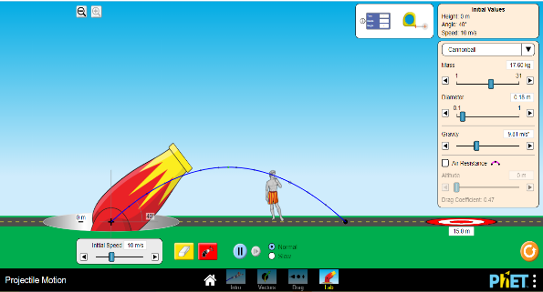
Figure 2. PhET Virtual Laboratory Simulation

In Figure 2, the first step to be taken is to open the PhET virtual laboratory media and follow the guidelines and set up the existing tools by measuring the elevation angle of 42° : 45° : 48°, initial speed of 10 m/s, acceleration of gravity 9.81 m/s² , and a height of 0 m : 1 m : 2 m. For more details, data collection will be grouped with the following Table 1.

Table 1. Analysis of Elevation Angle Against Maximum Distance and Travel Time
Elevation Angle (θ) | Height (m) | Initial Speed ​​(m/s) | Gravity (m/s²) | Maximum Distance (m) | Travel Time(s)
θ₁ | h | v | g
θ₂ | h | v | g
θ₃ | h | v | g

if θ ₁ > θ₂, so tan θ₁ > tan θ₂ - x tan θ₁ > tan θ₂, or it can also be written with x tan θ₁ < tan θ₂

, it can also be written with the following equation by, so
(3)
based on equation 3 produce equation y₁ < y₂. After data analysis has been obtained and clearly proven, then a comparison will be made of whether an elevation angle of 45° will produce the farthest maximum distance or not by using a function graph.

Results and Discussion
The results data analysis were obtained from the use of the PhET Virtual Lab which was then processed into mature data. A summary of the data from the results of the research analysis is presented in the following table

Table 2. The Results of Analysis of Elevation Angle Against x - t (h = 0 m)
Elevation Angle (θ) | Height (m) | Initial Speed ​​(m/s) | Gravity (g) | Maximum Distance (x) | Travel Time (t)
48º | 0 | 10 | 9.8 | 10.14 | 1.52
45º | 0 | 10 | 9.8 | 10.19 | 1.44
42º | 0 | 10 | 9.8 | 10.14 | 1.36

In Table 2, it can be seen that there is a different comparison between angles 48º and 42º with 45º in terms of time, and at 42º it has a relatively faster time. But at an angle of 48º and 42º have the same distance. To facilitate understanding in Table 2, the following is a graphic presentation shows that at an angle of 45º the curve is the highest, which means that at a height of 0 m the angle of 45º will produce the farthest distance, but at angles of 48º and 42º it will produce the same distance at 10.14 m.

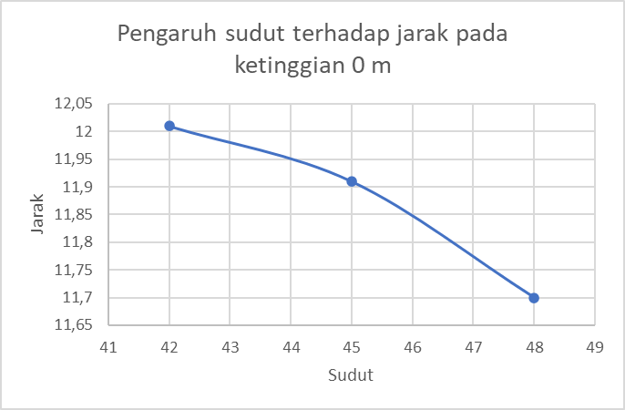  (a) | 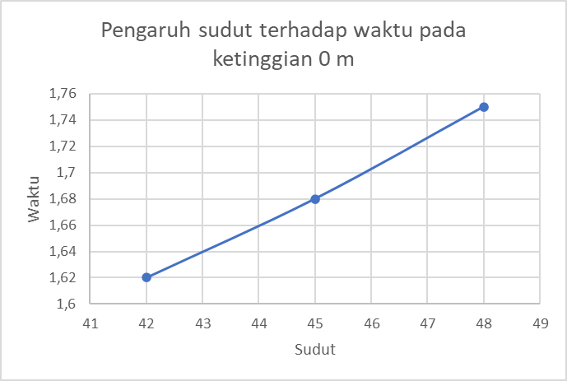  (b)
Figure 3. (a) Effect of angle on distance at a height of 0 m, (b) Effect of angle on time at a height of 0 m

The graph Figure 3 shows that at an angle of 42º gets the lowest result, which means that at an angle of 42º has the fastest travel time compared to the other angles even though at the distance traveled, the angle of 42º has the fastest relative time compared to the angle of 48º which has the same distance at the distance.

Table 3. Results of Analysis of Elevation Angle Against, x - t (h = 1 m)
Elevation Angle (θ) | Height (m) | Initial Speed ​​(m/s) | Gravity (g) | Maximum Distance (m) | Travel Time(s)
48º | 1 | 10 | 9.8 | 10.97 | 1.64
45º | 1 | 10 | 9.8 | 11.11 | 1.57
42º | 1 | 10 | 9.8 | 11.15 | 1.50

Table 3, it can be seen that there is a different comparison between angles 48º and 42º with 45º in terms of travel distance, and has a relatively faster time at 42º. Figure 4 presents a representation of the graph of the relationship between distance to time and distance to angle of inclination at height (h = 1 meter).

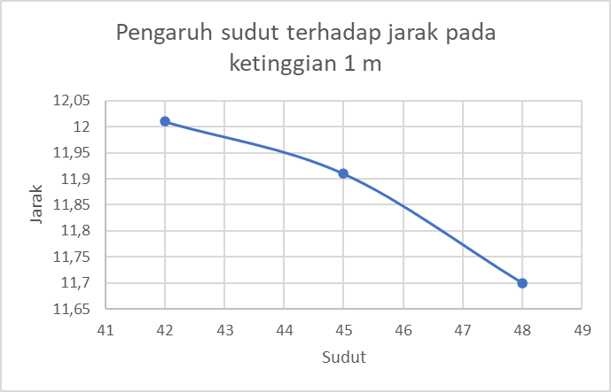  (a) | 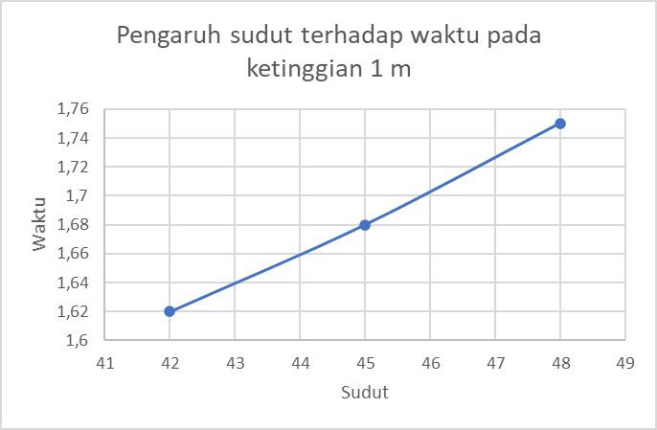  (b)
Figure 4. (a). Effect of Angle on Distance (h = 1 m), (b). Effect of Angle on Time (h = 1 m)
Figure 4 shows that at an angle of 42o the highest value is obtained, which means that at an altitude of 1 m the angle of 42o will produce the farthest distance, but at an angle of 48o the distance traveled is no longer the same as 42o, the angle of 48o gets smaller results compared to other angles. This is also inversely proportional to graph 1, where the 45o angle no longer gets the farthest distance. The graph (a) shows that angle 42o still gets the smallest value, this is still the same as graph (b). Then angle 42o still has the fastest travel time compared to other angles, and angle 48o still has a relatively longer travel time.
Table 4 shows a different comparison between angles 48º and 42º with 45º, and the same comparison as in table 3 in terms of travel distance, angle 42o has the same farthest distance as in table 3, and has a relatively long time return faster at 42º, this shows the same comparison as in Table 3. presents a representation of the graph of the relationship between distance to time and distance to angle of inclination at height (h = 2 meter).

Table 4. Results of Analysis of Elevation Angle Against, x - t (h = 2 m)
Elevation Angle (θ) | Height (m) | Initial Speed ​​(m/s) | Gravity (g) | Maximum Distance (m) | Travel Time (s)
48º | 2 | 10 | 9.8 | 11.70 | 1.75
45º | 2 | 10 | 9.8 | 11.91 | 1.68
42º | 2 | 10 | 9.8 | 12.01 | 1.62

From Table 4 can shows Figure 5, that the graph shows that angle 42º gets the highest return, this proves that at a height of 2 m, angle 42º gets the farthest distance, and angle 48º gets the shortest distance again compared to angles 45º and 42º. It also shows that Figure 5 is inversely proportional to Figure 4, and is directly proportional to Figure 3.

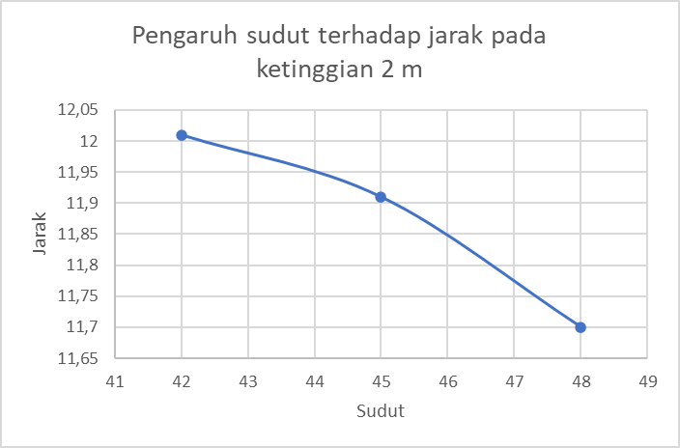  (a) | 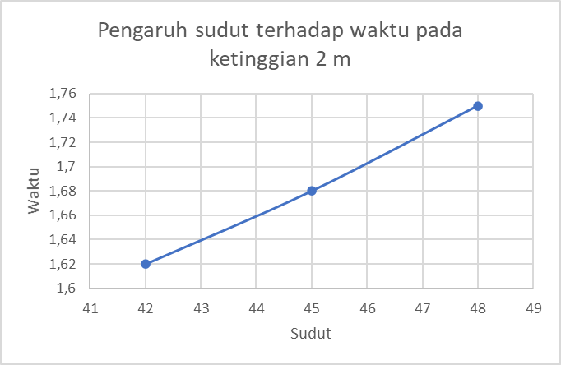  (b)
Figure 5. (a). Effect of Angle on Distance (h = 2 m), (b). Effect of Angle on Time (h = 2 m)

The graph shows that at an angle of 42º it still gets the smallest value, which means it shows at an angle of 42º it has a relatively fast travel time and also shows that on graphs 2, 4, 6, it has the same time difference, 42º the fastest travel time, and 48º the travel time the longest. Then after comparing each variable and also graphing the relationship, the three angles will produce their respective distances. By using the equation

, then the function graph can be displayed which will be presented by Figure 6.

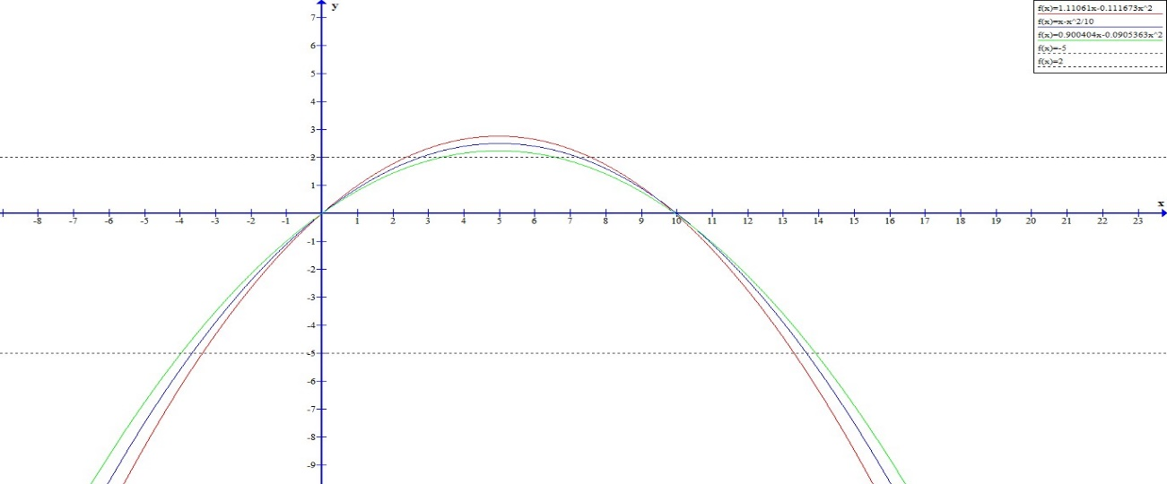
Figure 6. Graph of The Function x Angles 48º, 45º, and 42º
Figure 6 as the graph the red line represents the function value from an angle of 48o, the blue line represents 45º, and the green line represents 42º, it is also present the boundary between the ground and the roof is also given to show the difference in ball throws based on the x function.

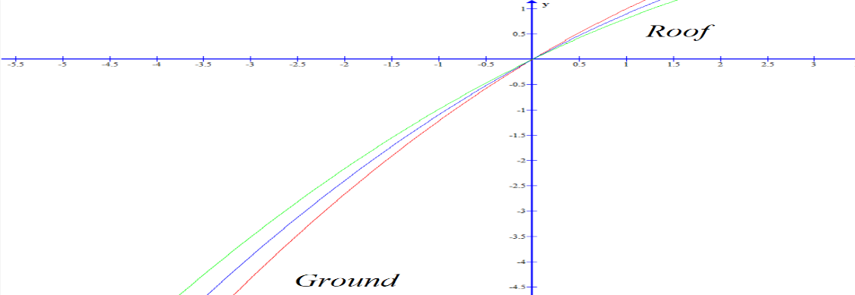
Figure 7. Graph of Function x Angles 48º, 45º, and 42º (Ground, Roof)

In the graph of this function (Figure 7), it can be seen that at point 0 the cartesian coordinate, it will get to the point of intersection between the three angles. On the Ground section, the 42º angle relatively gets the throw with the farthest starting position compared to the 45º angle which relatively gets the throw with the closest starting position compared to other angles. But on the roof, starting from the point (0,0) all corners start from the same starting position.

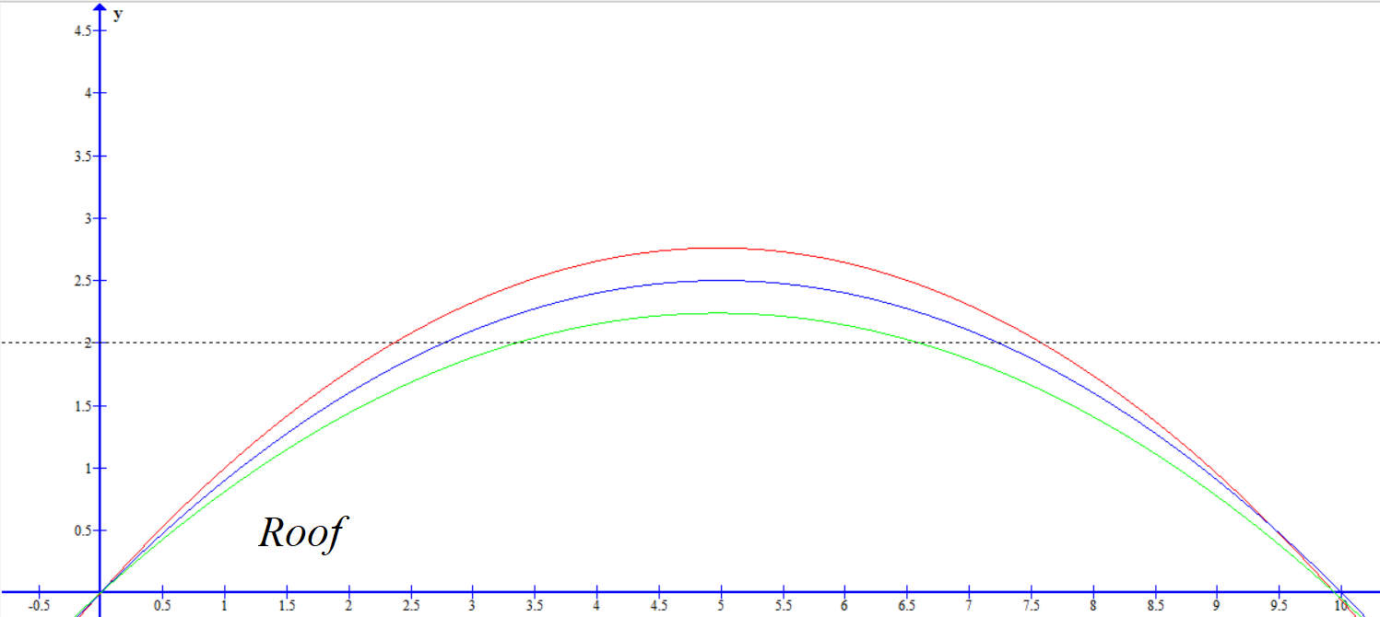
Figure 8. Graph of Function x Angles 48º, 45º, and 42º (Roof)
In the function graph (Figure 8) it can be seen that on the roof, the 48º angle will get the highest value compared to the other angles, and also the 42º angle will get the lowest height compared to the other angles. Meanwhile, on the roof, it can be seen that the resulting distance is the farthest 45º angle, this is because the x function is larger than the x function at other angles, but at angles of 48º and 42º, and will get the same result, and get point of intersection to go to ground. Which means at an angle of 45º, will get a superior starting value compared to other angles, angles 48º and 42º will get the same starting point.

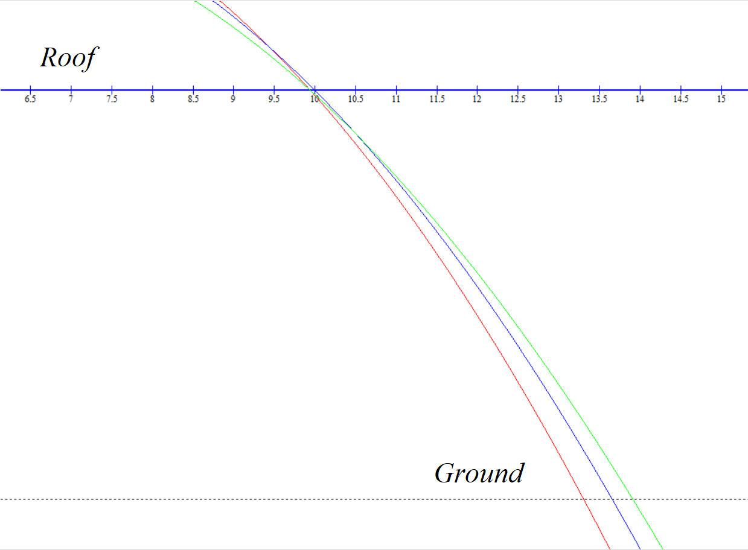
Figure 9. Graph of Function x Angles 48º, 45º, and 42º (Roof, Ground)
The farthest distance value compared to the other two angles. However, at an angle of 48º you get the shortest distance compared to the other two angles, at an angle of 45º you only get a small difference in value compared to 42º, this value can be seen in the table presented above. Objects coming from an angle of 45º on the roof show that objects with an angle of 45º have the farthest value in 1 condition, namely when the object starts from point (0,0). However, this is very difficult to find in real life, because Galileo himself stated that the projectile motion of his design only applies when in a vacuum and does not consider the initial altitude of the thrower.

Conclusion
In the experiment, proving the 45º angle to be the angle that produces the farthest distance is a misconception that has been circulating in Indonesian education circles. The 45º angle being the angle that produces the farthest distance only applies to 1 condition, namely the vacuum state which ignores the initial position of the thrower. This is impossible to find in real life, in which incidentally the throwers have a certain height, even mortar has an initial height that can be above the surface or below the surface. In this study, it was found that the angle of 42º has the farthest distance traveled in non-vacuum conditions, and also does not have to be in position (0,0). In addition, the 42º angle has a relatively faster travel time than the 45º angle. And also under certain conditions, a 42º angle and a 48º angle can get the same distance depending on the height. In this study, it is also hoped that readers will be able to reexamine the angle of producing the farthest distance. The data we get is also single data, due to the use of Virtual Lab which will produce the same data. Human error could have occurred in this study even with the use of the Virtual Lab.

References
[1] L. Nanjanee, H. I. Zulfa, and A. Alkomah, “Percobaan Gerak Parabola Dengan Papan Seluncur,” SPEKTRA J. Kaji. Pendidik. Sains, vol. 3, no. 2, p. 187, 2017, doi: 10.32699/spektra.v3i2.37.
[2] A. E. Kossovsky, The birth of a science, vol. 2, no. 5316. 1962. doi: 10.1136/bmj.2.5316.1380.
[3] B. R. H. Naylor, “Galileo’s Theory of Projectile Motion,” Isis, vol. 71, no. 4, pp. 550–570, 1980, doi: 10.1086/352592.
[4] S. Drake and J. MacLachlan, “Galileo’s Discovery of the Parabolic Trajectory,” Sci. Am., vol. 232, no. 3, pp. 102–111, Jan. 1975.
[5] J. Rajagukguk and C. Sarumaha, “Pemodelan Dan Analisis Gerak Parabola Dua Dimensi Dengan Menggunakan Aplikasi Gui Matlab,” J. Saintika, vol. 17, pp. 63–68, 2017.
[6] A. R. Aththibby, “Pengembangan Media Pembelajaran Fisika Berbasis Animasi Flash Topik Bahasan Usaha Dan Energi,” J. Pendidik. Fis., vol. 3, no. 2, 2015, doi: 10.24127/jpf.v3i2.238.
[7] M. Wakai and N. P. Linthorne, “Optimum take-off angle in the standing long jump,” Hum. Mov. Sci., vol. 24, no. 1, pp. 81–96, 2005, doi: 10.1016/j.humov.2004.12.001.
[8] Z. Hidayatullah, J. N. Nadhiroh, E. Kartika, A. A. Nuha, and S. Y. Erlangga, “Identifikasi Miskonsepsi Dan Konflik Kognitif Fisika: Kasus Terkait Perubahan KonseptuaL,” EDUSAINS, vol. 12, no. 1, pp. 64–71, 2020.
[9] R. H. Pangihutan et al., “Pengaruh Besar Sudut terhadap Jarak Lemparan pada Gerak Parabola,” no. 16013006, pp. 1–4.
[10] J. A. F. Castro and M. P. E. Morales, “‘Yin’ in a guided inquiry biology classroom - Exploring student challenges and difficulties,” J. Turk. Sci. Educ., vol. 14, no. 4, pp. 48–65, 2017, doi: 10.12973/tused.10212a.
[11] C. H. Belgacem, “ Analysis of projectile motion with quadratic air resistance from a nonzero height using the Lambert W function ,” J. Taibah Univ. Sci., vol. 11, no. 2, pp. 328–331, 2017, doi: 10.1016/j.jtusci.2016.02.009.
[12] A. O. Contreras, J. Juan Rosales García, L. M. Jiménez, and J. M. Cruz-Duarte, “Analysis of projectile motion in view of conformable derivative,” Open Phys., vol. 16, no. 1, pp. 581–587, 2018, doi: 10.1515/phys-2018-0076.
[13] A. Kuhlow, “Die Technik des Kugelstoßens der Männer bei den Olympischen Spielen 1972 in München,” 1975, Limpert, Frankfurt/Main.
[14] P. C. Li, “The impact statistical analysis of the shot throwing speed and angle on results based on numerical simulation,” vol. 8, pp. 198–203, Jan. 2013.
[15] D. Hammer, “More than misconceptions: Multiple perspectives on student knowledge and reasoning, and an appropriate role for education research,” Am. J. Phys., vol. 64, no. 10, pp. 1316–1325, 1996, doi: 10.1119/1.18376.
[16] N. Suprapto, “Do We Experience Misconceptions?: An Ontological Review of Misconceptions in Science,” Stud. Philos. Sci. Educ., vol. 1, no. 2, pp. 50–55, 2020, doi: 10.46627/sipose.v1i2.24.
[17] T. S. Tuhusula et al., “Eksperimen Menggunakan Virtual Lab Berbasis Phet Simulation Dalam Pembelajaran Fisika Pada Materi Gerak Parabola Program Studi Pendidikan Fisika , Universitas Cenderawasih Learning Physics On Parabolic Movement Materials,” no. 2, 2020.
[18] D. N. Sudjito, “Penggunaan modul praktikum mandiri berbasis simulasi phet dalam pembelajaran fisika tentang gerak parabola pada bidang datar,” Pros. Semin. Nas. MIPA, p. 16, 2019.
[19] S. I. Milatti and H. Fitrihidajati, “Pengembangan Lembar Kegiatan Peserta Didik Elektronik (E-Lkpd) Berbasis Problem Based Learning Pada Materi Perubahan Lingkungan Untuk Melatihkan Kemampuan Berpikir Kritis,” vol. 13, no. 1, 2024.
[20] E. Yulianti, N. N. Zhafirah, and N. Hidayat, “Exploring Guided Inquiry Learning with PhET Simulation to Train Junior High School Students Think Critically,” Berk. Ilm. Pendidik. Fis., vol. 9, no. 1, p. 96, Mar. 2021, doi: 10.20527/bipf.v9i1.9617.
[21] C. L. Harum, M. Syukri, Y. Yusrizal, and C. Nurmaliah, “Pengaruh Model Pembelajaran Generatif Berbasis PhET Terhadap Keterampilan Berpikir Kritis dan Motivasi Belajar Siswa pada Materi Gelombang,” J. Pendidik. Sains Indones., vol. 8, no. 2, pp. 164–174, Oct. 2020, doi: 10.24815/jpsi.v8i2.15776.
[22] I. R. Nugroho and B. Ruwanto, “Pengembangan Media Pembelajaran Fisika Berbasis Media Sosial Instagram Sebagai Sumber Belajar Mandiri Untuk Meningkatkan Motivasi dan Prestasi Belajar Fisika Siswa Kelas XI SMA”.
[23] D. Misbahudin, C. Rochman, D. Nasrudin, and I. Solihati, “Penggunaan Power Point Sebagai Media Pembelajaran: Efektifkah?,” WaPFi Wahana Pendidik. Fis., vol. 3, no. 1, p. 43, Feb. 2018, doi: 10.17509/wapfi.v3i1.10939.
[24] M. Davies and R. Barnett, Eds., The Palgrave Handbook of Critical Thinking in Higher Education. New York: Palgrave Macmillan US, 2015. doi: 10.1057/9781137378057.
[25] W. Khumairok, A. Y. R. Wulandari, N. Qomaria, and L. K. Muharrami, “Profil Keterampilan Berpikir Kritis Siswa Smp Pada Materi Getaran Gelombang Dan Bunyi Menggunakan Soal Berbantuan Prompting Question,” Nat. Sci. Educ. Res., vol. 4, no. 1, pp. 35–44, Jul. 2021, doi: 10.21107/nser.v4i1.8353.

[26] N. W. S. Darmayanti and L. S. Utami, “Penerapan Metode Latsol (Latihan Soal) Materi Pelajaran Fisika Melalui Kegiatan Bimbingan Belajar Di Luar Jam Sekolah Untuk Mengatasi Kesulitan Belajar Fisika Siswa Smp Di Desa Gontoran, Kecamatan Lingsar, Lombok BaraT,” SELAPARANG J. Pengabdi. Masy. Berkemajuan, vol. 2, no. 1, p. 35, Nov. 2018, doi: 10.31764/jpmb.v2i1.562.
[27] A. J. Patandean, N. Natalia, and A. Swandi, “Analisis Kesulitan Belajar Fisika Siswa SMK di Halmahera Barat,” J. Ilm. Ecosyst., vol. 23, no. 2, pp. 317–325, Aug. 2023, doi: 10.35965/eco.v23i2.2856.

